NAME: Chaluvadi Jwala Satya Saketh

Reg.no.: RA2011028010071

EXPERIMENT 4:

CREATING A STATIC WEBSITE ON AMAZON S3 USING THE AWS SYSTEM MANAGER

**AIM:** To create a static website on Amazon S3 using AWS system manager.

**PROCEDURE:**

1. Sign in to the AWS Management Console and click on Amazon S3 Console at https://console.aws.amazon.com/s3/
2. Click on create a bucket.
3. Enter the name of the bucket and the region you want to create it in
4. 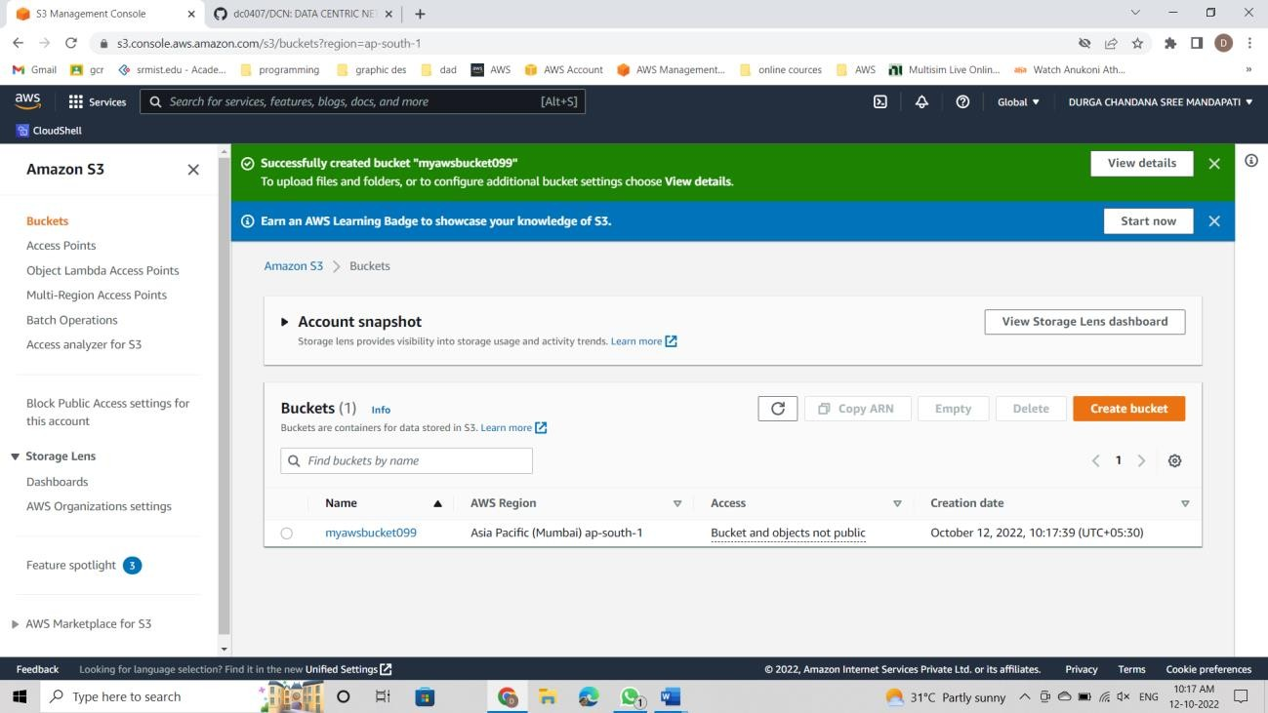Accept the default settings and then click on create a bucket age.
5. In the buckets list, click on the bucket you just created and choose properties, then under static website hosting click the enable option.

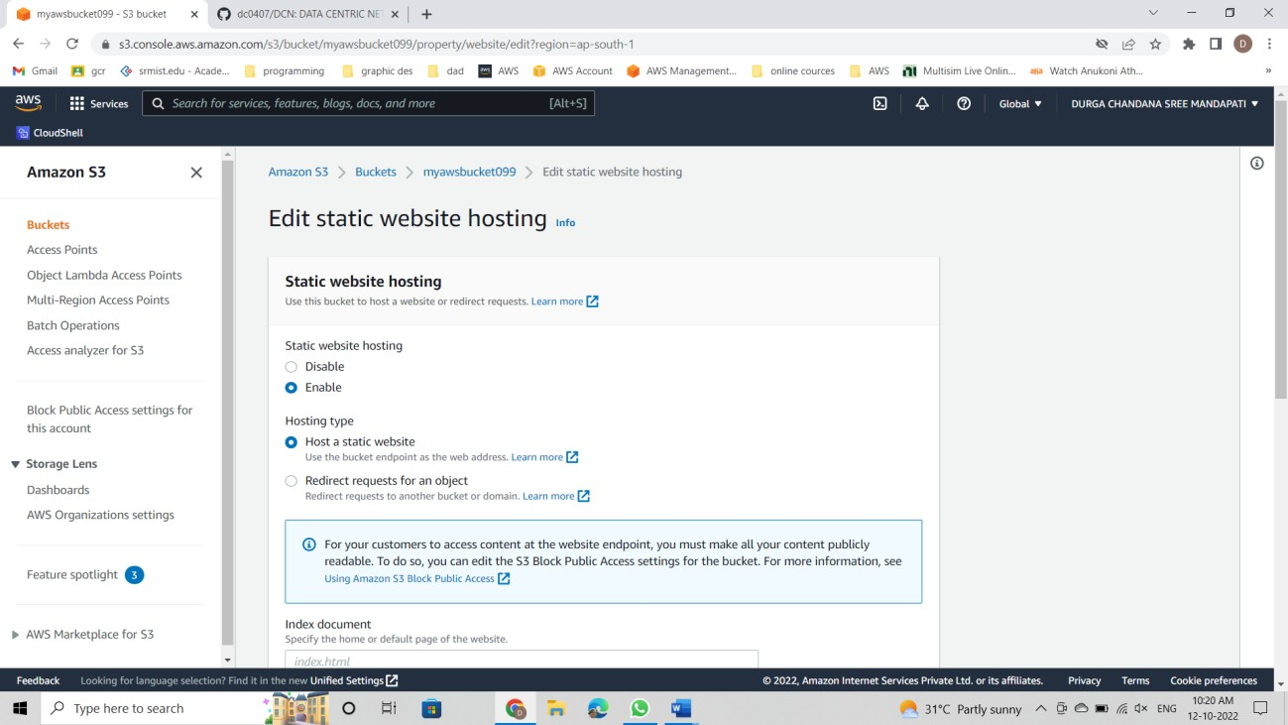

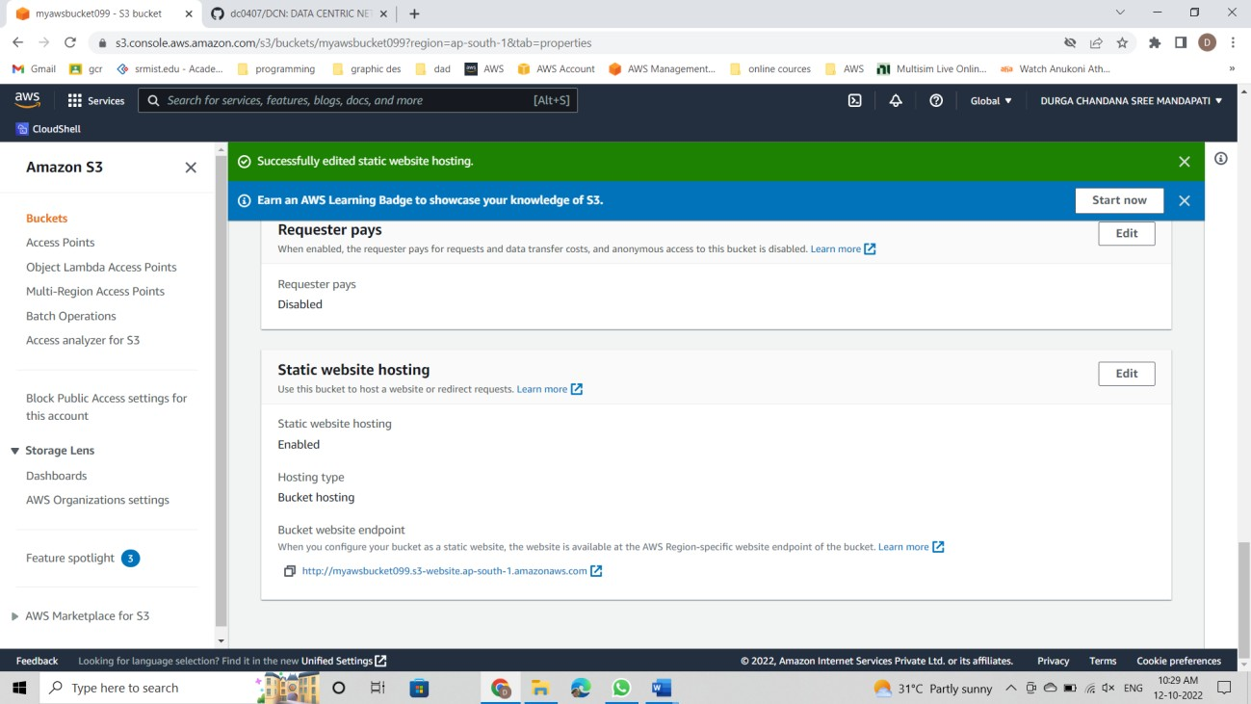

1. Then click on the upload option after selecting your bucket and upload your project files(index.html, style.css,main.js). Also, make sure that the project files you will upload have proper names as they are case-sensitive.

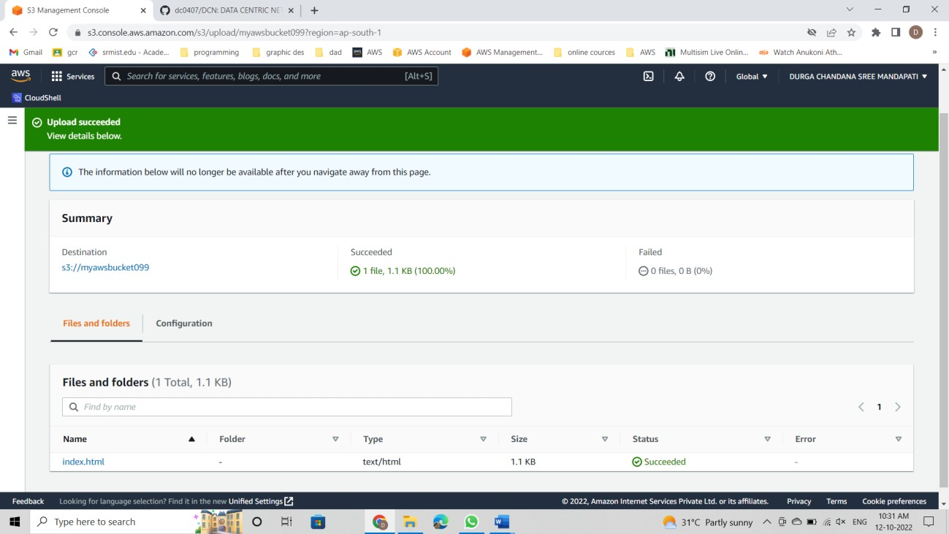

1. After configuring the website, you can use the endpoint to test the website out.
2. choose the name of the bucket you just configured and then choose permissions under that block public access will be visible, click on the edit option and save the changes.
3. 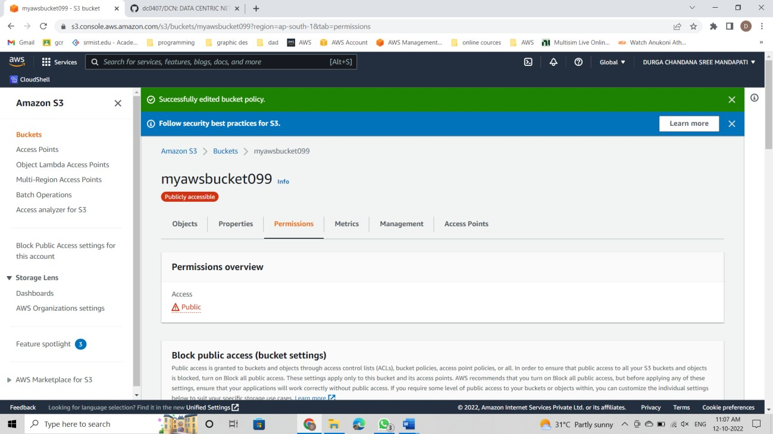under the bucket permissions there will be a bucket policy, click on that and paste this code into the bucket policy editor:

{

"Version": "2012-10-17",

"Statement": [

{

"Sid": "PublicReadGetObject", "Effect": "Allow",

"Principal": "*",

"Action": [ "s3:GetObject"],

"Resource": [ "arn:aws:s3:::myawss3bucket1/*"

]

}

]

}

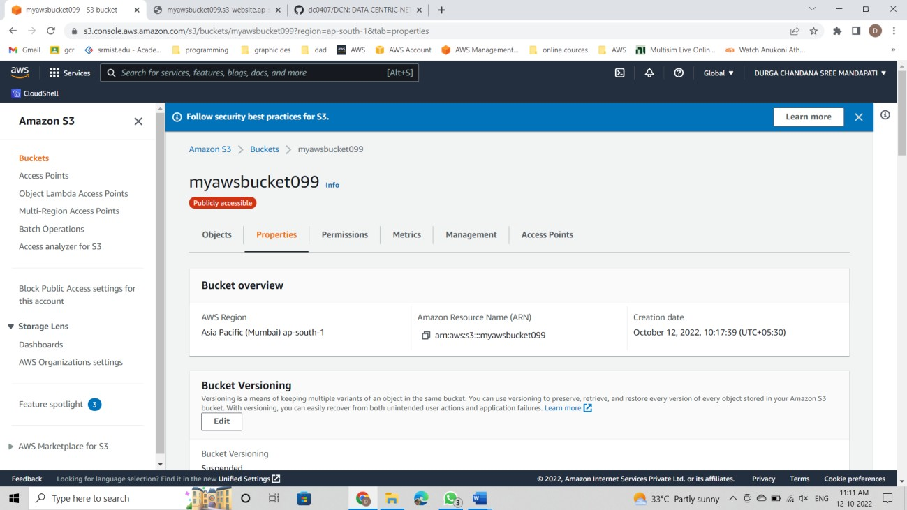

1. Click on save changes
2. Under the buckets, choose the name of your bucket which you just created, and in the properties, choose a static website hosting - then choose your bucket endpoint
3. Now you can access your website as it has successfully been hosted.

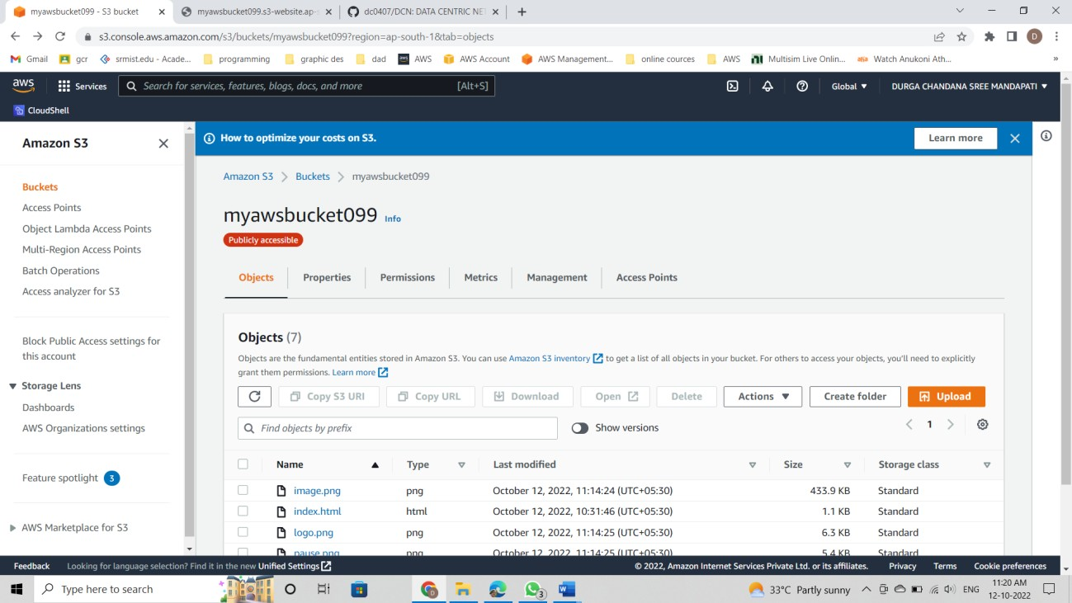

<http://myawsbucket099.s3-website.ap-south-1.amazonaws.com/>

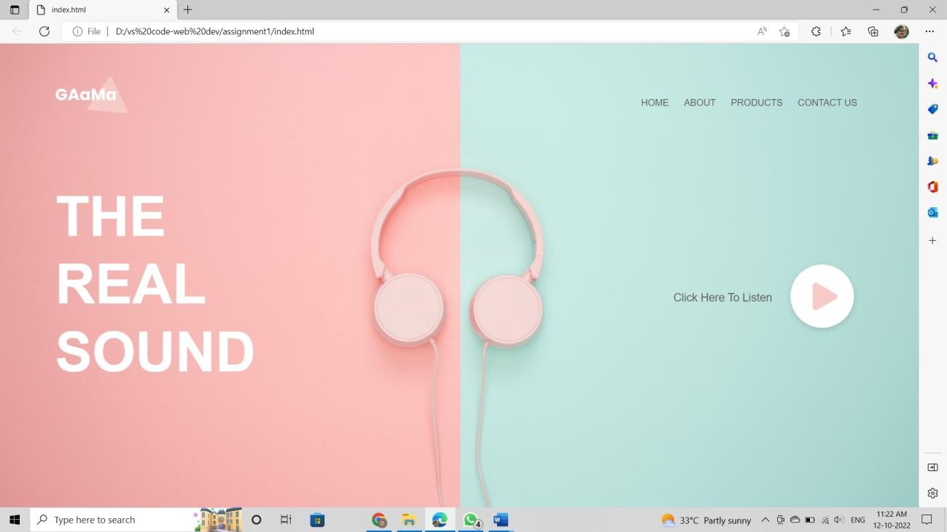

1. Make sure to clean up after this experiment by deleting the AWS Resources that have been just allocated . After you have deleted these resources, your website will no longer be available .

**RESULT:**

A static website has been successfully created on Amazon S3 using AWS System Manager.